Party Guest Information

Your child has been invited to a Go Wild! Party at The Willows Horringer; where they provide enriching activities that give children aged 2-12 the opportunity to immerse themselves in a safe ‘Forest School’ setting. Go Wild! Parties offer a range of outdoor activities and games. Your child will have the opportunity to cook on an open fire and be encouraged to use tools and take managed risks; whilst having fun and enjoying the great outdoors.
To ensure they have the best time ever, please dress your child in suitable outdoor clothing and footwear. It is recommended that guests wear; long sleeves and trousers, wellies/old tainers. A kit bag conatining a waterproof coat, sun/wooly hat and spare clothing/footware is also advisable. We have a pond and raft on site, so please bring wellies and spare footwear.
The Willows Horringer can be found at Farm Cottage, Chevington Road, Horringer, IP29 5SW (the first property on your right as you enter the village from the direction of Chevington, or last on your left when exiting the village from the direction of Bury). Please arrive at the time stated on the invitation; to meet the host and other guests, before heading down to the site.
Before the big day, please can you kindly read the permission statements overleaf to consent to your child’s participation.

We look forward to seeing you at the Go Wild! Party
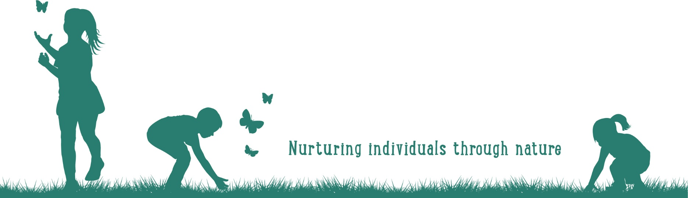
www.thewillowshorringer.com

You have been invited to _______________________

Go Wild! Party at The Willows

On _________________________ at _________________

There will be adventurous activities for us to enjoy!

We will be eating butchers sausages in rolls and s’mores,
if you have any dietary requirements, please let us know 14 days before the big day.

Please read the statements below and RSVP

to ______________________________________ 14 days before the party

Activity Consent
At the Go Wild! Party your child may have the opportunity to take part in the activities listed below. If your child attends the Go Wild! party you give consent for your child to participate in:
- Den building
- Fire lighting/cooking on an open fire (with adult supervision)
- Bug hunting
- Balancing bridges and low ropes
- Raft riding
- Swinging on the tyre and rope swing
- Whittling using vegetable peelers/knives (over 7 years old)
- Natural arts and crafts
- Tree climbing (no higher than 3 meters)
- Using tools, including mallets, drills and saws
Any activity involving ‘managed risk’ is carefully assessed. Tool procedures/instructions and safety guidance is given at the beginning of each activity. The Willows does not take responsibility for any injury that your child causes to them self because they have not followed our procedures and guidance.
Photo Consent
At the Go Wild! Party photographs may be taken for the organisers personal use and for marketing purposes (to be used by The Willows, to advertise future events). Children will not be identified by name in the photos. If you do not wish photos to be taken of your child please let the party organiser know when you RSVP.
Personal Information
We require a contact name and number (parent or guardian) just in case we need to contact you during the party. Please ensure the organiser has this information prior to the big day. This information will be gathered and stored responsibly by the organiser.
Medical Information and Consent to First Aid
Please let the party organiser know if you child:
- has asthma, allergies (including food allergies) or other medical conditions that the organiser or staff at The Willows need to be aware of
- is taking any medication that may affect their experience at the party
- has had an allergic reaction to a bee or wasp sting
By attending the party you consent for a qualified first aider to administer first aid to your child, if required.

