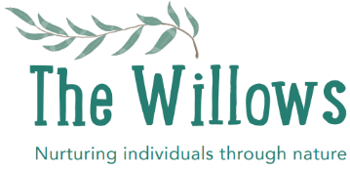
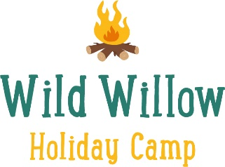

Consent and Permission Form

I have booked my child ______________________(name) into camp on ___________________ (date)

I have made a payment of £30.00 to Rebecca Dodman 40-15-22 11498622, with my child’s name as reference.

I will provide the appropriate clothing required to meet my child’s needs (listed in the information leaflet) and a drink/packed lunch if staying in camp all day.

Personal Information
Childs’ full name and date of birth

Home address

Parents name and contact details
Alternative contact name and number

Medical Information
Does your child have asthma, allergies (including food allergies) or other medical conditions that we might need to know about? If ‘yes’ please provide further details.
Please provide details of any medication that your child is currently taking that may affect their experience at the party.
Has your child ever had an allergic reaction to a bee or wasp sting? If ‘yes’ please provide further details.

By signing and printing your name below you give permission for a member of staff (with outdoor first aid certification) to administer first aid to your child if required.

Activity Consent
By signing and printing your name below you give permission for your child to participate in the planned tasks listed below:
- Shelter/den building
- Balancing bridges and low ropes
- Raft riding
- Swinging on the tyre and rope swing
- Bug hunting
- Whittling using vegetable peelers/knives
- Wild arts and crafts
- Mud sculpting
- Tree climbing (no higher than 3 meters)
- Cooking on an open fire (with adult supervision)
- Using tools, including mallets and saws
Wild Willow Holiday Camp does not take responsibility for any injury that a child causes to them self because they have not followed our rules, procedures and guidance.

Photo Consent
At Wild Willow Holiday Camp photographs may be taken for marketing purposes; to be used by Rebecca Doman; to advertise future camps. Children will not be identified by name in the photos, unless direct communication is made with the child’s parents/carers. By signing and printing your name below you give permission for photos of your child to be taken and used in this way.

Data Protection and Confidentially
All information provided is covered by the Data Protection Act and is strictly confidential.
I fully understand and agree to the above information being held by Rebecca Dodman for the duration of the event. Printed consent forms will then be disposed of according to GDPR.

Booking Terms and Conditions
Please contact us as soon as possible if you need to cancel your child’s place. Once you have booked onto Wild Willow Holiday Camp (by returning the consent form and making full payment) you have made a commitment that your child will attend. The session fee is payable whether or not your child attends (unless the club is full and we have been able to allocate your place to another child). Please sign below to indicate that you agree to these terms and conditions.

__________________________ __________________________ _______________________
Signature of Parent/Carer Print Name Date

Please complete, sign and return to rebecca@thewillowshorringer.com

